CLOUD WATCH

1. Which CloudWatch metrics would you monitor (ALB, EC2, application-level)?
ALB (Application Load Balancer) – CloudWatch Metrics
These tell you traffic, health, and latency.
Traffic & Load
- RequestCount – Total incoming requests (capacity & scaling signal)
- ActiveConnectionCount – Current open connections
- NewConnectionCount – Sudden spikes indicate traffic surges
Health & Errors
- HealthyHostCount / UnHealthyHostCount – Backend instance health
- HTTPCode_Target_5XX_Count – App-side failures (very important)
- HTTPCode_ELB_5XX_Count – Load balancer issues (rare but critical)
Latency
- TargetResponseTime – End-to-end response time from targets
👉 Used for: detecting app failures, scaling decisions, and user experience issues.

EC2 – Instance-Level Metrics
These tell you resource usage and instance health.
Core Metrics (Default)
- CPUUtilization – High CPU = scaling or optimization needed
- NetworkIn / NetworkOut – Traffic volume
- DiskReadOps / DiskWriteOps – I/O activity
Health
- StatusCheckFailed – Instance or hardware failure
- StatusCheckFailed_Instance
- StatusCheckFailed_System
With CloudWatch Agent (Important)
- MemoryUtilization – Not available by default
- DiskSpaceUtilization
- SwapUsage
👉 Used for: autoscaling, performance tuning, and failure detection.

Application-Level Metrics (Custom Metrics)
These tell you how your app is actually behaving
Performance
- ApplicationLatency
- ResponseTime (p95 / p99)
Errors
- ApplicationErrorCount
- FailedLoginAttempts
- ExceptionCount
Business / Functional Metrics
- OrdersPlaced
- TransactionsProcessed
- QueueDepth
- CacheHitRatio
Logs-Based Metrics
- Extract metrics from logs using CloudWatch Logs Insights
- Example: count HTTP 500s from application logs
👉 Used for: SLA monitoring, alerting, and business health.
Typical Alarms You’d Set (Bonus)
- CPU > 70% for 5 mins → Scale out
- UnHealthyHostCount > 0 → Alert
- HTTP 5XX spikes → App issue
- TargetResponseTime > threshold → Latency alert

🔹 One-Line Interview Summary
“I monitor ALB metrics for traffic and errors, EC2 metrics for resource health, and application-level custom metrics for performance and business impact.”
ALB Metrics:
“I monitor RequestCount, TargetResponseTime, and HTTP 5XX errors to track traffic load, application latency, and backend failures. HealthyHostCount helps ensure targets are serving properly.”
EC2 Metrics:
“I track CPUUtilization, NetworkIn/Out, Disk I/O, and StatusCheckFailed to monitor instance performance and health. I also use CloudWatch Agent for memory and disk space monitoring.”
Application-Level Metrics:
“I monitor custom metrics like response time, error rate, and transaction count to understand application performance and business impact. These help in SLA monitoring and proactive alerting.”

2. Would you use standard or custom metrics, and why?
“I would use both standard and custom CloudWatch metrics because they serve different monitoring purposes and together provide complete observability.
Standard metrics are automatically available in CloudWatch for AWS services like ALB, EC2, RDS, etc. This help monitor infrastructure health and performance. For example, CPUUtilization, Network traffic, RequestCount, TargetResponseTime, and instance status checks help identify resource bottlenecks, traffic spikes, and system failures. They are easy to use and require no additional configuration.
Custom metrics, on the other hand, are used to monitor application-level and business-level performance, which standard metrics cannot capture. For example, application response time, error rate, number of successful transactions, queue depth, or user login failures. These metrics help measure SLA compliance, user experience, and application reliability.
Using both standard and custom metrics helps in end-to-end monitoring, faster troubleshooting, better alerting, and improved decision-making for scaling and performance optimization

3. How would you configure CloudWatch Alarms and SNS topics?
Configuring CloudWatch Alarms and SNS Topics
🔹 What is the Purpose?
- CloudWatch Alarm → Monitors metrics (CPU, memory, etc.) and triggers action when threshold is crossed.
- SNS Topic → Sends notifications (Email, SMS, Lambda, etc.) when alarm is triggered.
👉 Example: If EC2 CPU > 80%, send email alert.

🟢 Step 1: Create SNS Topic
1. Go to SNS Service
- Login to AWS Console
- Search → Simple Notification Service (SNS)
2. Create Topic
- Click Topics
- Click Create topic
- Choose:
  - Type → Standard
  - Name → HighCPUAlert
- Click Create topic

3. Create Subscription
- Open created topic
- Click Create subscription
Fill Details:
- Protocol → Email / SMS / Lambda / HTTPS
- Endpoint → Enter email ID or phone number
Example:
Protocol: Email
Endpoint: example@gmail.com
👉 Confirm subscription from email.

🟢 Step 2: Create CloudWatch Alarm
1. Open CloudWatch
- Go to AWS Console
- Search → CloudWatch

2. Create Alarm
- Click Alarms
- Click Create Alarm

3. Select Metric
Example (EC2 CPU monitoring):
- Click Select Metric
- Choose:
EC2 → Per Instance Metrics → CPUUtilization
- Select instance
- Click Select metric

4. Configure Threshold
Example:
Threshold type → Static
Whenever CPUUtilization is → Greater than 80%
Evaluation:
Period → 5 Minutes
Evaluation Period → 2
👉 Alarm triggers if CPU > 80% for 10 minutes.

5. Configure Actions
- Select:
Send notification to SNS topic
- Choose Topic:
HighCPUAlert

6. Add Alarm Name
Example:
EC2-High-CPU-Alarm
Click Create Alarm

🟢 Step 3: Test the Alarm
Ways to Test:
- Increase CPU load manually
- Run stress command in EC2:
stress --cpu 2 --timeout 300
👉 Once threshold crosses → SNS sends notification.

🟢 Architecture Flow
CloudWatch monitors metric
↓
Alarm threshold crossed
↓
Triggers SNS Topic
↓
SNS sends Email / SMS / Lambda

✅ Real-Time Use Cases
- EC2 high CPU or memory alerts
- RDS storage full alerts
- Auto scaling triggers
- Billing alerts
- Application failure alerts
⭐ Interview Ready Answer (Short)
"CloudWatch alarms are configured to monitor AWS resource metrics and trigger actions when thresholds are breached. SNS topics are used as notification services. First, we create an SNS topic and subscription, then configure a CloudWatch alarm, select the required metric, set threshold conditions, and attach the SNS topic for alert notification."

4. Handling SNS Delivery Failures
🔹 What is SNS Delivery Failure?
SNS delivery failure happens when SNS cannot deliver messages to subscribers like:
- Email not confirmed
- Lambda execution error
- SQS permission issues
- HTTP endpoint down
- SMS delivery failure

🟢 1. Enable Dead Letter Queue (DLQ) – Best Practice ⭐
👉 What is DLQ?
A Dead Letter Queue stores messages that SNS failed to deliver after retries.
👉 How to Configure
Step 1: Create SQS Queue
- Go to SQS
- Create queue (Example: SNS-Failure-DLQ)

Step 2: Attach DLQ to SNS Subscription
- Go to SNS
- Select Topic → Subscription
- Edit subscription
- Enable Redrive Policy
- Select SQS DLQ
👉 Failed messages will be stored here for analysis.

🟢 2. Configure Retry Policy
SNS automatically retries message delivery for certain protocols.
Example Retry Behaviour:
- HTTP/HTTPS endpoints
- Lambda
- SQS
You can configure:
- Retry interval
- Maximum retry attempts
- Backoff strategy
👉 Helps recover temporary failures.

🟢 3. Monitor SNS Delivery Status with CloudWatch
Enable SNS delivery logging.
Steps:
- Open SNS topic
- Enable Delivery Status Logging
- Send logs to CloudWatch
You can monitor:
- Success count
- Failure count
- Latency
- Throttling errors

🟢 4. Validate Subscriber Endpoint
Common production checks:
✔ Email
- Confirm subscription link
- Check spam filtering
✔ Lambda
- Check IAM permissions
- Check function timeout
- Review CloudWatch logs
✔ HTTP Endpoint
- Ensure endpoint is reachable
- Verify SSL certificate
- Validate response status (must return 200 OK)
✔ SQS
- Ensure SNS has permission to send messages
- Check queue policy

🟢 5. Implement Alerting on Failures
Create CloudWatch alarms for:
- SNS delivery failure metric
- DLQ message count increase
👉 Helps detect issues quickly.

🟢 6. Message Replay / Redrive
Once issue is fixed:
- Retrieve messages from DLQ
- Reprocess manually or via automation

🟢 Real Production Example
Example scenario:
CloudWatch Alarm → SNS Topic → Lambda
If Lambda fails:
- SNS retries delivery
- If still fails → Message goes to DLQ
- DevOps team investigates logs
- Fix Lambda issue
- Replay message from DLQ

⭐ Interview Ready Answer
"To handle SNS delivery failures, I configure Dead Letter Queues to store undelivered messages, enable retry policies for temporary failures, and monitor delivery status using CloudWatch logs and metrics. Additionally, I validate subscriber endpoints and implement alerting on failure metrics to ensure message reliability."

5. How would you filter notifications so only critical alerts trigger SMS?
The clean way to do this is SNS message filtering.
✅ Filtering Notifications so Only Critical Alerts Trigger SMS
🔹 Core Idea
You don’t create multiple alarms for every channel.
Instead, you:
- Publish all alerts to one SNS topic
- Attach different subscriptions
- Use Filter Policies so:
  - 🔔 Email gets all alerts
  - 📱 SMS gets only CRITICAL alerts

🧠 High-Level Flow
CloudWatch Alarm
↓
SNS Topic (single)
↓
Message attributes (severity=critical/warning)
↓
SNS Filter Policy
↓
Only CRITICAL → SMS

🟢 Step 1: Use Message Attributes (MOST IMPORTANT)
When an alarm publishes to SNS, it includes message attributes like:
{
"severity": "critical",
"service": "ec2",
"environment": "prod"
}
CloudWatch alarms support this via Alarm Actions → Additional settings → Message attributes.

🟢 Step 2: Create SNS Subscriptions
Let’s say you have one SNS topic:
Prod-Alerts-Topic
Subscriptions:
Protocol | Target | Purpose
Email | team@company.com | All alerts
SMS | +91XXXXXXXXXX | Only critical alerts

🟢 Step 3: Apply SNS Filter Policy to SMS Subscription
This is where the magic happens ✨
SMS Subscription Filter Policy
{
"severity": ["critical"]
}
✅ Result:
- Only messages with severity=critical go to SMS
- Warnings & info are silently ignored

🟢 Step 4: (Optional) Filter by Multiple Conditions
Example: Only critical alerts from PROD EC2
{
"severity": ["critical"],
"service": ["ec2"],
"environment": ["prod"]
}
This avoids:
- Test alerts
- Dev/stage noise
- Non-EC2 alerts waking you up 😴

🟢 Real Production Example
Alarm Mapping
Alarm | Severity | Notification
EC2 CPU > 90% | critical | SMS + Email
Disk > 80% | warning | Email only
ALB 5xx spike | critical | SMS + Email
Billing alert | info | Email only

🟢 Alternative (Less Recommended)
You could create:
- One SNS topic for SMS
- One SNS topic for Email
❌ But this causes:
- Duplicate alarms
- Harder maintenance
- More config drift
👉 Filter policies are cleaner and scalable

⭐ Interview-Ready Answer
“I use SNS filter policies with message attributes. All alarms publish to a single SNS topic with attributes like severity. SMS subscriptions have a filter policy that allows only severity=critical, while email subscriptions receive all alerts. This ensures only high-impact issues trigger SMS notifications.”

6. How do you monitor disk space usage on EC2 using CloudWatch, since it’s not available by default?
You’re right: EC2 disk space is NOT available by default in CloudWatch.
Here’s the correct, real-world way to monitor it.

✅ Monitoring Disk Space on EC2 using CloudWatch
🔹 Why Disk Metrics Are Missing by Default
By default, CloudWatch provides hypervisor-level metrics like:
- CPUUtilization
- NetworkIn / Out
- DiskReadOps / DiskWriteOps
❌ It does NOT know what’s happening inside the OS (like filesystem usage).
👉 To get disk usage, we must use the CloudWatch Agent.
🟢 Solution: Install CloudWatch Agent
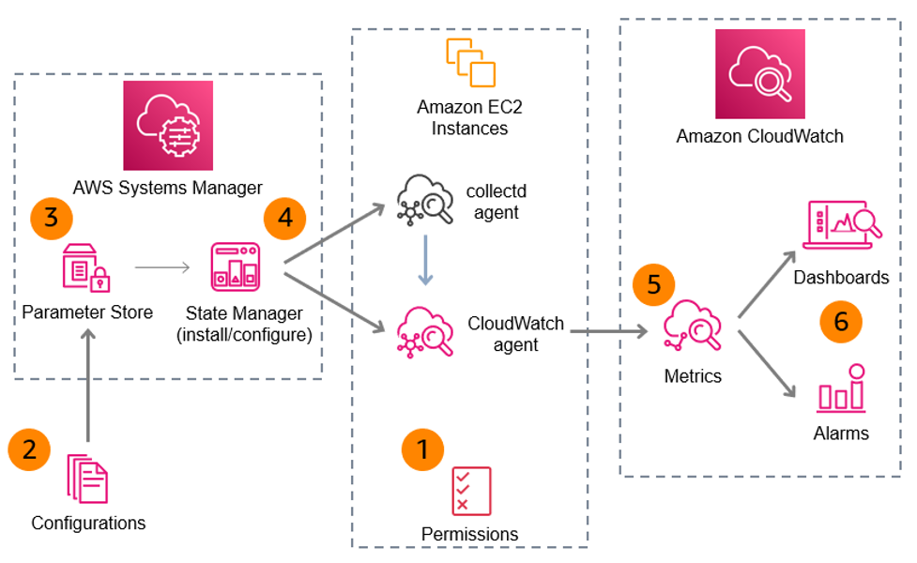
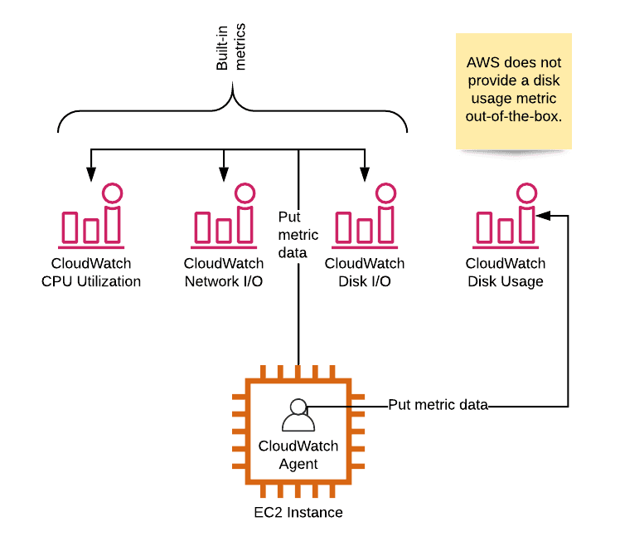
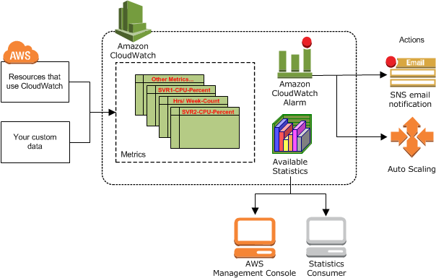
What CloudWatch Agent Does
- Runs inside EC2 OS
- Collects disk, memory, swap, filesystem metrics
- Pushes them as custom metrics to CloudWatch
🟢 Step 1: Attach IAM Role to EC2
Attach an IAM role with:
CloudWatchAgentServerPolicy
This allows EC2 to push metrics.
🟢 Step 2: Install CloudWatch Agent
Amazon Linux / RHEL
sudo yum install amazon-cloudwatch-agent -y
Ubuntu
sudo apt update
sudo apt install amazon-cloudwatch-agent -y
🟢 Step 3: Create Agent Configuration
Run the config wizard:
sudo /opt/aws/amazon-cloudwatch-agent/bin/amazon-cloudwatch-agent-config-wizard
Choose:
- Metrics → Yes
- Disk usage → Yes
- Filesystem → /
- Measurement → used_percent
👉 This creates:
/opt/aws/amazon-cloudwatch-agent/etc/amazon-cloudwatch-agent.json
🟢 Step 4: Start CloudWatch Agent
sudo systemctl start amazon-cloudwatch-agent
sudo systemctl enable amazon-cloudwatch-agent
🟢 Step 5: Verify Metrics in CloudWatch
Go to:
CloudWatch → Metrics → CWAgent → disk → used_percent
You’ll see:
- Disk usage %
- Per filesystem
- Per EC2 instance
🟢 Step 6: Create CloudWatch Alarm (Disk Usage)
Example alarm:
Metric: disk_used_percent
Threshold: > 80%
Period: 5 minutes
Evaluation: 2
Attach SNS for alerting.
🟢 Alternative: Custom Script (Not Preferred)
You can push disk usage via cron + AWS CLI:
df -h | awk ...
aws cloudwatch put-metric-data ...
❌ Not scalable
❌ No auto-dimensions
❌ Hard to maintain
👉 CloudWatch Agent is best practice
⭐ Interview-Ready Answer
“Disk usage is not available by default in CloudWatch because it’s an OS-level metric. To monitor it, I install the CloudWatch Agent on EC2, attach the required IAM role, configure disk metrics like disk_used_percent, and then create CloudWatch alarms based on those custom metrics.”
🔥 Production Best Practices
- Monitor used_percent, not free space
- Set different thresholds for:
  - Root volume
  - Application volume
- Combine with:
  - Auto scaling
  - Log cleanup automation
- Use SSM + State Manager for mass deployment

7. CloudWatch Metrics vs CloudWatch Logs – How to Decide
🔹 Simple Difference
CloudWatch Metrics | CloudWatch Logs
Numerical data | Text/event data
Used for monitoring performance | Used for troubleshooting
Fast alerting | Deep debugging
Aggregated data | Detailed raw data

🟢 When to Use CloudWatch Metrics
👉 Use Metrics when you want numbers + trends + alerting
Examples:
- CPU usage
- Memory utilization
- Disk usage %
- Request count
- Error rate %
- Latency
Best For:
✔ Real-time monitoring
✔ Threshold-based alerts
✔ Dashboards & graphs
✔ Auto scaling triggers

Example Scenario
If your application is slow:
You first check:
- CPU spike?
- Memory leak?
- Increased latency?
👉 Metrics help identify "Something is wrong"

🟢 When to Use CloudWatch Logs
👉 Use Logs when you want detailed root cause analysis
Examples:
- Application exceptions
- Stack traces
- API request failures
- Authentication failures
- Database connection errors
Best For:
✔ Debugging issues
✔ Root cause analysis
✔ Security auditing
✔ Transaction tracking

Example Scenario
If users report login failure:
Metrics show:
- Error rate increased
Logs show:
- Exact exception message
- Failed user request details
👉 Logs tell "Why it is wrong"

🧠 Real Production Thought Process
Step 1: Detect Issue → Metrics
Example:
- 5xx errors increased
- Response time high
- CPU usage spiked
Metrics answer:
Is there a problem?
How severe is it?
When did it start?

Step 2: Investigate Issue → Logs
Then check logs to find:
Which API failed?
What exception occurred?
Which request caused failure?

🟢 Decision Rule (Golden Interview Answer)
👉 Use Metrics for detection
👉 Use Logs for diagnosis

🟢 Real DevOps Example
Scenario: Website Down
Metrics Shows:
- ALB 5xx errors ↑
- EC2 CPU normal
- Response time ↑
Logs Shows:
- Database connection timeout
- Credential failure
- Code exception

🟢 When You Should Use BOTH (Best Practice ⭐)
Most production systems combine:
Metrics
- Trigger alarms
- Monitor trends
- Auto scale
Logs
- Provide debugging details
- Support incident response

🟢 Advanced Pattern (Used in Production)
You can convert logs into metrics using:
👉 CloudWatch Metric Filters
Example:
- Count number of "ERROR" logs
- Create alarm if error count > threshold

⭐ Interview-Ready Answer
"I use CloudWatch Metrics to monitor performance and detect issues using numerical indicators like latency, error rate, and resource utilization. Once an issue is detected, I use CloudWatch Logs to analyze detailed application events and identify the root cause. Metrics help identify that a problem exists, while logs help explain why it occurred."

🔥 Bonus (Senior-Level Insight)
Use Metrics When:
- You need alerting
- You need trending data
- You need auto scaling triggers
Use Logs When:
- You need debugging
- You need transaction-level details
- You need security investigation

7. How do you integrate CloudWatch with Auto Scaling and SNS for automated alerting and recovery?
This covers automated monitoring + alerting + self-healing architecture, which is a real DevOps production design.

✅ Integrating CloudWatch with Auto Scaling and SNS for Automated Alerting & Recovery
🔹 Overall Goal
Automatically:
- Detect failures or high load
- Alert DevOps teams
- Recover infrastructure without manual action
Flow:
Application / EC2 Metrics
↓
CloudWatch Monitoring
↓
CloudWatch Alarm
↙ ↘
Auto Scaling SNS
Recovery Alerting

🟢 Step 1: Monitor Resources using CloudWatch
CloudWatch collects metrics like:
- CPU utilization
- Memory (via agent)
- Disk usage
- Request count
- ALB latency / error rate
👉 These metrics act as the trigger source.

🟢 Step 2: Configure CloudWatch Alarm
Example:
Metric → EC2 CPUUtilization
Threshold → Greater than 80%
Period → 5 minutes
Evaluation → 2 times
When threshold is crossed:
- Alarm state changes → ALARM

🟢 Step 3: Integrate with Auto Scaling (Recovery Action)
Attach Auto Scaling Policy to CloudWatch Alarm.

✔ Scaling Out (High Load Recovery)
Example:
If CPU > 80%
Add 2 new EC2 instances
This ensures:
- Traffic is distributed
- Performance is restored
- No manual intervention required

✔ Scaling In (Cost Optimization)
Example:
If CPU < 30%
Terminate 1 instance

🟢 Step 4: Integrate with SNS (Alerting)
Same CloudWatch alarm can also:
- Send email alerts
- Send SMS alerts
- Trigger Lambda
- Notify Slack / Teams

Example Alert Message:
ALERT: Production CPU exceeded 80%
Auto Scaling triggered
2 new instances launched
👉 Keeps operations team informed.

🟢 Step 5: Multi-Layer Recovery (Advanced Production Setup)
Layer 1 → Auto Scaling
Automatically replaces unhealthy instances.
Layer 2 → Load Balancer Health Checks
Removes failed instances from traffic.
Layer 3 → SNS Notification
Alerts DevOps / On-call team.

🟢 Step 6: Self-Healing Example Scenario
Scenario:
Traffic suddenly spikes.
What Happens:
- CloudWatch detects CPU spike
- Alarm triggers
- Auto Scaling launches new instances
- ALB routes traffic to new instances
- SNS sends alert notification
👉 Application recovers automatically.

🟢 Real Production Example
E-Commerce Sale Traffic Spike
Users increase
↓
CPU & latency increase
↓
CloudWatch alarm triggers
↓
Auto Scaling launches instances
↓
SNS alerts SRE team
↓
System stabilizes

🟢 Best Practices ⭐
✔ Use multiple metrics (CPU + Request count + Latency)
✔ Use Step Scaling or Target Tracking policies
✔ Add cooldown period to avoid frequent scaling
✔ Use SNS severity filtering
✔ Combine with health checks
✔ Enable detailed monitoring

🟢 Advanced Automation Pattern
You can also:
- Trigger Lambda for remediation
- Restart services automatically
- Clean disk space
- Rollback deployment

⭐ Interview-Ready Answer
"I integrate CloudWatch with Auto Scaling and SNS by configuring CloudWatch alarms on key metrics like CPU utilization or latency. When thresholds are breached, the alarm triggers Auto Scaling policies to automatically add or remove instances for recovery and performance stability. At the same time, SNS sends notifications to the operations team for visibility and incident response. This setup enables automated alerting and self-healing infrastructure."

🔥 Senior-Level Insight
CloudWatch provides:
- Detection
Auto Scaling provides:
- Recovery
SNS provides:
- Communication
👉 Together they create self-healing and observable infrastructure

